CUSTOMER REQUIREMENT SPECIFICATION

 |  |  |  | Document Ref.:
 |  |  |  | Version No.: |  |  | 1
 |  |  |  | Date : |  |  | 26th February 2020
 | Project Name: | Connected Living Spaces
 | Project Code: | PW20CBR01M
 | Status: | Current
 | Document Type: | Controlled / Uncontrolled
 | Connected Living Spaces
 | Smart Automation for educational institutions- Access Control Systems, Facial Recognition, Mood Detection and Rejuvenation,Automation of appliances,Automatic Cooling and Heating Systems,Temperature monitoring and Leakage detection.
 | Prepared By: |  |  |  | Reviewed By:
 | Name |  | Date |  | Name |  |  | Date
 | Chirag N Vijay |  | 26/02/20
 | DG Sudheer |  | 26/02/20 |  | Approved By:
 |  |  |  |  | Name |  |  | Date
 | Dhanush Ravi |  | 26/02/20
 | Distribution List
 | Project Representative(s) |  |  |  |  | Guide Representative(s)
 | - Chirag N Vijay  - DG Sudheer  - Dhanush Ravi |  |  |  |  | - Prasad Honavalli  - Charanraj B R

TABLE OF CONTENTS

Definitions, Acronyms and Abbreviations 3
References 3
Change History 4
1.0 Introduction 5
1.1 Scope 5
2.0 Product Perspective 5
2.1 User Characteristics 6
2.2 General Constraints, Assumptions and Dependencies 6
2.3 Risks 6
3.0 System Architecture 7
4.0 Requirements List 7
4.1 Module / Scenario 1 7
4.2 Module / Scenario 2 7
4.3 Module / Scenario n 8
5.0 External Interface Requirements 8
5.1 Hardware Requirements 9
5.2 Software Requirements 9
5.3 Communication Interfaces 10

6.0 Traceability Matrix 10

Definitions, Acronyms and Abbreviations
- IOT-Internet of Things
- MQTT- Message Queueing Telemetry Transport
- DHT-Digital Humidity and Temperature
References
- Sensor based home automation and security system - M. H. Assaf, R. Mootoo, S. R. Das, E. M. Petriu, V. Groza and S. Biswas, 2012 IEEE

- Microcontroller based Home Security System with Remote Monitoring - Nikhil Agarwal, 2012 ICEDSP

- Room Temperature Control and Fire Alarm/Suppression IoT Service Using MQTT - Do-Hun Kang, Min-Sung Park, 2017 PlatCon

- Messaging Queue Telemetry Transport IOT based Messaging Protocol - Suvam Mohanty & Sagar Sharma , Vaibhav Vishal, 2016 IRJET

- IoT real time data acquisition using MQTT protocol - R A Atmoko & R Riantini , Vaibhav Vishal, 2016 ICoPLA

Change History
This section describes the details of changes that have resulted in the current CRS document.

# | Date | Document Version No. | Change Description | Reason For change

Introduction
This document relates to the background and surrounding information regarding our project - Emotion detection using voice data. It deals with the scope, shortcomings, risks, architecture, etc. of the project and is meant to serve as documentation to the end-user who wishes to understand the project in detail and modify it to achieve better results.

Scope
With the digitalization of almost and everything the previous decade saw the rise of automating houses and offices with the advent of IOT and Industrial IOT.
Being a fairly new industry there is a scope for widespread innovation from scratch.
The modules can be used independently also as separate products.
Development of facial recognition systems, automatic heating, cooling, access control and leakage detection systems.

Product Perspective

Since it is a product designed to integrate the other products such as lights, fans, heaters, cameras in a smart way, it is a semi-independent product.
The product comprises of the following modules: -
- Access Control Systems – Automatic secure access control system with ability to lock and unlock various doors with the tap of a button and logging in important data like the number of locks ,number of unlocks ,latest Intime and Out-time of the locks in the Graphical UI and a persistent database .RFID based access control system is developed as a backup to the developed access control system. Facial Recognition system developed can be used parallelly for access control.
- Automatic cooling and heating Systems – The GUI allows us to access the temperatures of different zones and different rooms .Based on the reading of the temperatures the heating system is activated when the temperature falls below the lower threshold and the cooling system is activated when the temperature goes above the upper threshold.
- Lights, Mood detection and appliance control – A smart lighting system is developed which increases the luminosity of the lighting system in accordance with the solar level. Users can control and manipulate lights and other light duty appliances. Mood detection is done with input from the user’s own Spotify account and adjusts the lighting based on the user’s mood.
- Leakage detection – Leakage detection systems are developed which monitor the gas levels, water levels and alerts the user regarding the same. A fire alarm is also activated when a fire breaks out. The data regarding the previous leaks is recorded in a persistent database.
- Security System – A separate security system is developed which provides complete surveillance which is again backed up to a persistent database and a burglar alarm system is also integrated and there’s a system assigned for the monitoring of heavy duty appliances like geysers, air conditioners and other high duty appliances.
- Voice Control – All the above systems can be controlled by voice commands through Alexa and google assistant.

User Characteristics
The users are characterized in a level-based hierarchy.
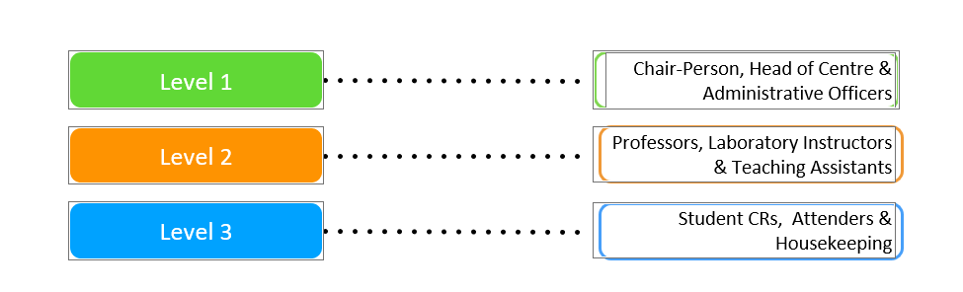

General Constraints, Assumptions and Dependencies
Hardware Dependencies: -
- An ubuntu 18.04 desktop to act as the main server.
- A laptop/PC/Mobile/Tablet for viewing the GUI.
- The CLS Box which consists of the development board and helps control every appliance
- Sensors – Gas, Water, Temperature, Light Intensity, Presence Detection
- Electromagnetic locks, fans, lights, appliances, heater, exhaust fan.
- Wires
Software Dependencies
Python 3.7, Spotify,Spotipy,face_recognition,Arduino IDE, MQTT ,ESP32 Libraries
Other Important Dependencies
- Wi-Fi
- Electricity

Risks
The following are the risks which can seriously affect the working of the product.
- Hardware Failures
- Pests biting wires
- Power Failures

System Architecture
Depict the initial requirements architecture diagram and give a brief explanation about the same or Context Diagram (Level “0” DFD) for the system being developed.
For Example:

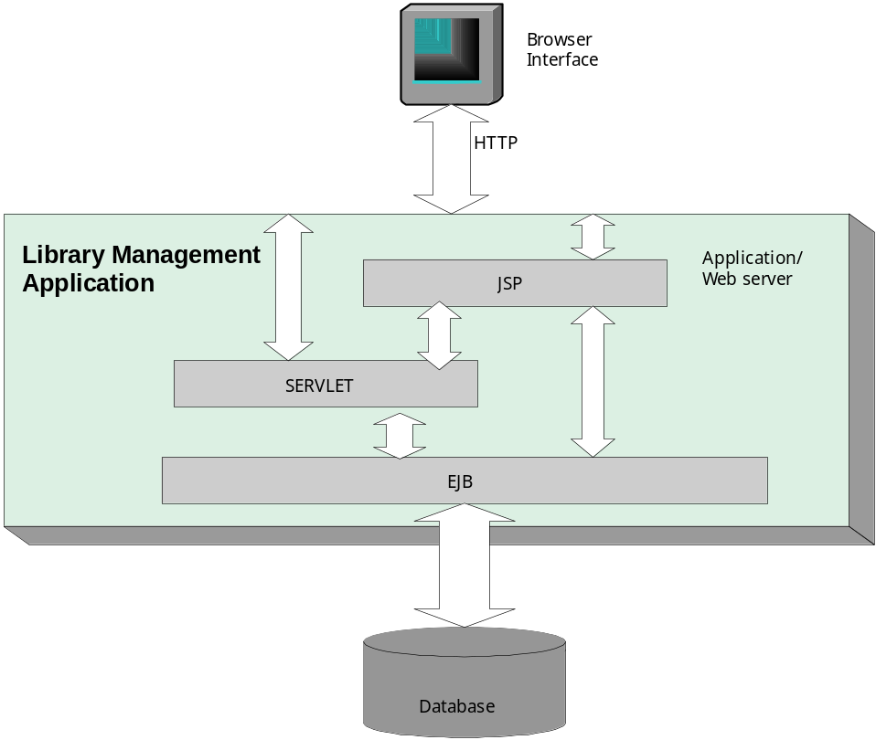
Your explanation comes here.

Requirements List

Module / Scenario 1
Reqmt # | Requirement
CRS – 1 | Access Control System

Module / Scenario 2
Reqmt # | Requirement
CRS – 2 | View and control temperature

Module / Scenario 3
Reqmt # | Requirement
CRS – 3 | Automatic cooling and heating system

Module / Scenario 4
Reqmt # | Requirement
CRS – 3 | Controlling lights

Module / Scenario 5
Reqmt # | Requirement
CRS – 3 | Solar based light intensity control

Module / Scenario 6
Reqmt # | Requirement
CRS – 3 | Mood detection

Module / Scenario 7
Reqmt # | Requirement
CRS – 3 | Facial Recognition

Module / Scenario 8
Reqmt # | Requirement
CRS – 3 | Gas leakage detection

Module / Scenario 9
Reqmt # | Requirement
CRS – 3 | Water leakage detection

Module / Scenario 10
Reqmt # | Requirement
CRS – 3 | Fire alarm

Module / Scenario 11
Reqmt # | Requirement
CRS – 3 | Surveillance

Module / Scenario 12
Reqmt # | Requirement
CRS – 3 | Burglar Alarm

Module / Scenario 13
Reqmt # | Requirement
CRS – 3 | Heavy duty appliance monitoring

External Interface Requirements

5.1 Hardware Requirements
Server – Ubuntu 18.04 ,8 GB RAM,1 TB HDD,2GB Nvidia Graphics
Working sensors
FTF, MTM, MTF Wires

Software Requirements
This section shall specify the use of other required software products (e.g. a data management system, an operating system, or a mathematical package), and interface with other application systems (e.g. the linkage between an accounts receivable system and a general ledger system).
For each required product the following shall be provided
- Name and Description
- Version / Release Number
- Source (if any)
Access Control Systems
- Arduino IDE 1.8.9
- PubSubClient 2.7.0
- Wi-Fi 1.2.7
- NTPClient 3.2.0
Temperature and automatic heating and cooling systems
- Arduino 1.8.9
- Dallas Temperature 3.8.0
- Onewire 2.3.5
- PubSubClient 2.7.0
Node-Red

Communication Interfaces
Node-Red: - Port: 1880
MQTT: - Port :1883

6.0 Traceability Matrix

URS Reference Section No. and Name | CRS Reference Section No. and Name

- The CRS is the basis for changes in specifications or requirements of the design in the project. It should be reflected in the Change History section.
- The CRS should state requirements and constraints clearly and concisely. Design details should not be included in the CRS.

